

**TEAM ASSIGNMENT 4**

**Software Process And Quality Management**

**Team 5 K16T1**



**CONTENTS**

|  |  |  |  |
| --- | --- | --- | --- |
| Date | Version | Author | Description |
| 24/09/2013 | 1.0 | Dao Khau | Create Document |
| 17/12/2013 | 1.1 | Dao Khau | Update Document |

1. MEMBER LISTS: 1

2. INTRODUCTION: 1

2.1. DOCUMENT PURPOSE: 1

2.2. REFFERENCES AND RELAVENT DOCUMENTS: 1

3. BACKGROUND: 1

3.1. CHARACTERS: 1

3.2. EVENT: 2

4. HOW WERE THAY USED? 5

5. CONCLUSION: 8

6. ASPECTS OF THE MODELS: 9

7. REFLECTION 10

**REVISIONS**

# MEMBER LISTS:

|  |  |
| --- | --- |
| T103573 | Le Ngoc Chau |
| T105026 | Khau Thanh Dao |
| T104898 | Huynh Trong Khang |
| T101184 | Ta Ngoc Thien Phu |
| T103569 | Nguyen Hoang Fa Thu |
| T094054 | Trinh Thai Anh |

# INTRODUCTION:

## DOCUMENT PURPOSE:

* This document is designed for description team assignment 4 for Software Process and Quality Management course.
* The document focus on description the case of Estimation as a Tool.
* Background: Goals of the case study, Characters and Events.
* Analysis and evaluation.
* What did people do correct.
* What they need to change.

## REFFERENCES AND RELAVENT DOCUMENTS:

* Reading[21]: [21-Estimation_as_a_Tool.pdf](https://hoctructuyen.vanlanguni.edu.vn/file.php/620/Readings/21-Estimation_as_a_Tool.pdf)

# BACKGROUND:

## GOALS OF THE CASE STUDY:

* See a situation and learn how to assess and analyze different situations quickly.
* Learn how to read tell tail signs from a project to look for patterns.
* Learn how to ask and answer questions from the information in front of you in the case.
* Finally learn how to relate cases to real life projects.

## CHARACTERS:

|  |  |
| --- | --- |
| Name | Description |
| Marvin Saymore | Marvin Saymore is Junior engineer.  He was being asked to estimate his ﬁrst full project after starting his new job with Transad. |

## EVENT:

|  |  |
| --- | --- |
| ID | Event |
| E01 | Marvin Saymore had to give his boss an estimate, and he was not sure what the primary estimation issues on his projects were. |
| E02 | Marvin was still left with deciding what past, or, more accurately, what data from the past, he should use. |
| E03 | Marvin would accept that data used to follow the progress of a project were valid measurements. |
| E04 | Marvin believed would allow him to compare estimates and see which ones seemed more reasonable and in some ways see whether he was aware of all the major issues on the project. Dramatically different estimates for the same project using different techniques might indicate hidden issues or future problems. |
| E05 | Marvin first discovered, as he took over the reins as the new software manager at Transad, that metrics were fine for other people but not necessarily for his group. He found out that a number of metric efforts had been proposed |
| E06 | The historical data that was available was mainly “bean counter” data, that is, number of hours on the project, hours for preproduction, hours for postproduction, and repair hours in the field. |
| E07 | He used a simple technique over a short period of time that would enable him to understand clearly how each type of engineer spent his time. |
| E08 | Marvin wanted to see whether he could establish a correlation between the bean counter data and real data on his development projects. Table 3-4 gives the resulting data that Marvin obtained |

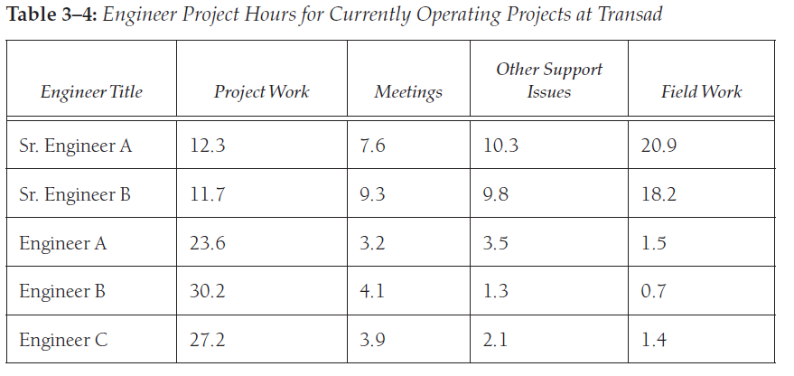

# WHAT DID PEOPLE DO CORRECT

* **Using more than one way to estimate the project:**

Using more than one way provide many estimation results so that we can make a comparison then get a more reasonable estimation. Besides, different estimation for the same project can indicate hidden issues and future problems.

* **Using a simple technique over a short period of time to collect data from engineers:**

According to estimation concept, we should perform estimation throughout the project so that we can justify and get more accurate estimation. Therefore, collect data over a short period of time can provide a comparison between actual and estimation data then we use it as a base to re-estimation to close the gap.

* **Look for similarity in projects:**

To use history data in estimation, we must find out similar project. Because of, similar project can provide accurate metrics or similar significant events to estimation. Thus, we can make a best estimation.

* **Finding significant events which have 80/20 effect on his project estimates in sameness projects:**

Significant events which contributed a large amount of time in the sameness projects can occur in current project. So identify those events can provide a full sight about which tasks can make heavy influence to time of project then focus in them. Because, according to 80/20, 80% amount of time of project cause by 20% task in that project. It surely increases accuracy of our estimation.

* **Making a plan to update estimation process:**

Process improvement is very important, it make estimation results more accurate

* **Discovered that metrics were fine for other people but not necessarily for his group**

None of metric efforts had been maintained for a long period of time or were used to predict future performance. Historical data of company is not real accurate. Marvin can’t use it to estimate for his project. But he can use it to clearly understand what is he need estimates for his project

# WHAT THEY NEED TO CHANGE

|  |  |  |
| --- | --- | --- |
| What people did | What should people have done different | Reason |
| Indicated a “same” project is about half the original requirements had been modified, and about half of these modifications involved significant or moderate changes | Beside the same of requirement, people also pay attention to other issues such as human resource, technical, working environment...  To have a good estimation, PM should use some method or tool, which defined and used in the past: such as Wide Bendelphi. | Human resource, technical, working environment can also influence to the estimation. |

# REFLECTION

N/A